**HARDSURFACE**

**Comprehensive Documentation On:  
Name: Hard Surface  
Organization: Blacknibogames Studios  
Owner: Assadulah Sanusi   
Designer/Coder: Sokomba Chalcedony Ariel  
Website name: HARDSURFACE  
Program: Project Skill Application  
Semester Outcome: Creating a full-stack website using ~~React~~ and PHP  
Semester: Semester 2**

**Cover Page**

**Title:** Comprehensive Documentation for the Hard Surface Modeler Platform  
**Author:** Sokomba Chalcedony Ariel  
**Date:** February 6 2025

**Table of Contents**

1. **Introduction** ..................................................... Pages 1–2
2. **Problem Statement** .............................................. Pages 3–4
3. **Solution Statement** ............................................. Pages 5–6
4. **Methods Used to Gather Data** ......................... Pages 6–7
5. **System Architecture and Workflow** ............... Pages 8–10
6. **Implementation Details** ..................................... Pages 11–14
7. **Screenshots** ...................................................... Pages 15–20
8. **Impact on the Client** ......................................... Page 21
9. **Citations and References** .............................. Page 22
10. **End of documentation**……………………………….Page 23

*(Each chapter includes detailed explanations, sub-sections, and annotated diagrams where applicable. The numbers might not be accurate)*

**Page 1:**

**Chapter 1:**

**Introduction**

**Project Overview**

The purpose of this document is to detail the design, implementation, and operational workflow of a one-stop platform built specifically for a hard surface modeler who also serves as a lecturer. The core idea is to alleviate the burden of managing multiple online platforms by consolidating uploads, showcases, and feedback mechanisms into a single, streamlined website.

This platform was conceived after observing the limitations of existing solutions such as Patreon and YouTube, which, while powerful, do not fully cater to the niche requirements of professional 3D modelers and educators in emerging markets.

**Background & Motivation**

The client is a well-regarded hard surface modeler and lecturer whose work spans several disciplines. With responsibilities ranging from creating detailed models to preparing lectures and mentoring students, he has found that juggling multiple content platforms is unsustainable.

Challenges include:

* **Fragmented Presence:** Maintaining multiple accounts on many platforms.
* **Time Constraints:** Limited availability to update content regularly.
* **Local Accessibility:** Issues with data roaming and connectivity in Nigeria.

These challenges inspired the development of a dedicated platform that centralizes his digital presence and enhances interaction with his audience.

**Inspiration from Existing Platforms**

By closely analyzing platforms like Patreon and YouTube, several strengths and weaknesses were identified:

* **YouTube:** Excellent for video content and tutorials but limited for showcasing high-resolution model files and receiving nuanced technical feedback.
* **Patreon:** Provides a monetization model and community features; however, its interface is not tailored for the detailed presentation of 3D models or technical lectures.

**Page 2:**

* **Sketchfab:** A standard 3d asset library where 3D artists display they’re work in a simple interface which keeps it simple for visitors and other artists to navigate and download uploaded 3d assets.

The amalgamation of these insights led to the decision to create a hybrid platform that leverages the best aspects of both while addressing their shortcomings for our niche user.

**Objectives of the Platform**

The primary objectives include:

* **Centralization:** Images and contents made by the artist are stored on a single site.
* **Efficiency:** A simplified, data-light interface to accommodate local internet limitations.
* **Interactivity:** Built-in feedback and engagement tools to foster community interaction.
* **Professional Presentation:** Simple display features for intricate hard surface models.

**Scope and Structure of This Documentation**

This documentation details every aspect of the website—from initial conception and data collection methods to the technical workflow and client impact analysis. Subsequent chapters will delve deeper into the problem, the proposed solution, methods of research, system operation, and final implementation details.

Page 3:

**Chapter 2:**

**Problem Statement**

**1. Content Fragmentation**

The current ecosystem forces the client to use multiple platforms (YouTube, ArtStation, Patreon, Behance etc.). This fragmentation results in:

* **Scattered Data:** Difficulties in maintaining a cohesive portfolio.
* **Redundant Efforts:** Repeated uploads and management tasks.
* **Inconsistent User Experience:** Visitors must switch between platforms to see the full range of the client’s work.

**2. Challenges in 3D Design Recognition**

In a competitive 3D modeling industry, getting noticed is crucial. However:

* **Niche Focus:** Hard surface modeling is highly specialized.
* **Global vs. Local:** While international platforms offer vast audiences, local users (particularly in Nigeria) often face connectivity issues and data roaming limitations, reducing local engagement.
* **Lack of Customization:** Generic platforms do not highlight the technical nuances of hard surface modeling, making it hard to gain specialized recognition.

**3. Lecturer Duty and Overload**

Apart from creative work, the client is responsible for educating students in coding and design. This dual role creates:

* **Time Constraints:** Limited availability for consistent online engagement.
* **Management Overhead:** Juggling teaching responsibilities with content creation dilutes focus.
* **Quality vs. Quantity:** High-quality educational content requires time that is compromised by administrative overhead on multiple platforms.

**Page 4:**

**Local Data Roaming Issues**

In Nigeria, users frequently contend with:

* **High Data Costs:** Making heavy multimedia platforms less accessible.
* **Limited Connectivity:** Unreliable internet can hinder streaming and large file downloads.
* **Optimization Needs:** A lightweight, efficient system is essential for both the creator and the audience.

**Summary of the Problem**

Without a unified platform:

* The client continues to lose valuable time.
* The audience experiences inconsistent access.
* Recognition in the competitive 3D design space remains elusive.

These factors combine to form a strong impetus for a tailored solution that meets both creative and operational demands.

Based on other suggestions and feedback, users have mentions that inconsistent content and user interactions by the content creator could eventually fall back from sharing designs and the account becomes history. And if the user does return to the account, it would become difficult to regain the attention of visitors both new and old on any platform.

With this in mind, not just one but all accounts created could become history and so also the 3d artist

**Page: 5**

**Chapter 3:**

**Solution Statement**

**1. Overview of the Proposed Platform**

Our solution is a dedicated web platform designed to integrate all facets of the client’s professional and educational activities. Key features include:

* **Unified Interface:** One-stop shop for uploads, model showcases, and feedback.
* **User-Friendly Navigation:** Intuitive design that minimizes the learning curve.
* **Optimized Data Usage:** Lightweight pages ensure fast load times even on limited connections.

**2. Centralized Content Management**

By consolidating the client’s digital presence:

* **All-in-One Dashboard:** The platform enables the client to manage files, view analytics, and respond to feedback from a single interface.
* **Streamlined Updates:** A single upload automatically updates multiple sections (e.g., portfolio, blog, and news updates).

**3. Enhanced Engagement Mechanisms**

Interactive features are built into the platform:

* **Feedback and Commenting:** Users can leave detailed reviews on each model.
* **Rating System:** A built-in rating mechanism promotes quality work and encourages constructive feedback.
* **Discussion Threads:** Dedicated forums allow in-depth technical discussions relevant to hard surface modeling and lecture topics.

**4. Optimized for Local Accessibility**

Recognizing the connectivity challenges:

* **Data-Light Design:** The website uses optimized image and file compression techniques.

**Page:** 6:

* **Responsive Design:** Ensures smooth navigation on mobile devices, which are common among Nigerian users.
* **Caching Mechanisms:** Local caching strategies improve load times and reduce data consumption.

**Summary of the Solution**

The platform is a holistic solution that addresses the fragmented presence of the client’s work, enhances engagement, and ensures that even users with limited connectivity can access high-quality content. This design not only simplifies content management but also bolsters the client’s recognition within the specialized field of 3D design.

**Methods Used to Gather Data:**

**Research Methodology**

The design and functionality of this platform were informed by extensive research that combined both qualitative and quantitative methods. The process involved:

* **Online Surveys:** Gathering feedback from similar professionals and students.
* **Competitive Analysis:** Studying successful platforms (e.g., Patreon, YouTube, ArtStation) to understand best practices.
* **User Interviews:** Direct discussions with industry peers and educators.

**Insights from YouTube Channels**

Several influential YouTube channels were pivotal in shaping the design:

* **Blender Guru:** Offered guidance on visual presentation and the importance of a cohesive online identity. (maybe not directly)

**Page: 7**

* **CGMatter:** Shared techniques on automation and efficient content delivery which informed the platform’s lightweight design.
* **CGCookie:** Inspired by the simplistic flow of every element in a scene that would influence the final result (website)
* **TechWithTim:** The specific flow of how data can be transferred from once data file to another and how stacking layers of code could make simplistic code look complex

**Analysis of Industry Websites**

Key websites were scrutinized for layout, user experience, and monetization strategies:

* **ArtStation:** Inspired the portfolio presentation and high-quality image display.
* **Patreon:** Influenced the approach to community engagement and subscription models.
* **Gumroad:** Provided insights into direct sales and digital asset distribution.
* **Sketchfab:** Offered ideas on interactive model viewing, crucial for a 3D modeler’s portfolio.

**Comparative Analysis**

By comparing the functionalities of these platforms:

* **Strengths were identified,** such as Patreon’s robust community features.
* **Weaknesses were noted,** especially the limitations in handling detailed 3D models or educational content on platforms not built for that purpose.

This comparative analysis ensured that the final platform would not only incorporate the strengths but also address the shortcomings of existing solutions.

**Conclusion of Research Methods**

The data gathered provided a comprehensive understanding of:

* **User Needs:** From both the creator’s and the audience’s perspectives.
* **Technical Requirements:** Ensuring that the website is both efficient and robust.
* **Market Trends:** Aligning the solution with current industry standards and future developments.

Page: 8

**Chapter 5:**

**System Architecture and Workflow**

**Overview of System Architecture**

The system is built on a client–server architecture that prioritizes speed, security, and scalability. Key components include:

* **Front-End:** A bootstrap-driven interface that renders dynamic content based on user interactions.
* **Back-End:** A robust server-side engine that handles authentication, data processing, and file management.
* **Database:** A relational database optimized for fast query execution and secure data storage.

**User Authentication Flow**

**Login/Signup Process:**

* **User Registration & Login:** New users create an account using name, email and password verification. While the login simply request for name and password for simplicity
* **Authentication:** Secure login protocols are implemented to protect user data.
* **Session Management:** Active sessions are managed via encrypted cookies, ensuring both security and convenience.

**Homepage and Dashboard**

The homepage serves as the main gateway:

* **Dynamic Content Display:** The latest uploads and featured models are highlighted.
* **Navigation:** Clear links to sections such as the model showcase, upload area, and feedback modules.
* **Personalized Dashboard:** Registered users have access to a dashboard that displays personalized content, including recent activity and notifications.

Page: 9

**Detailed Workflow – Model Showcase**

**Model Showcase Page:**

* **Model Presentation:** Each model is displayed with high-resolution images, detailed descriptions, and technical specifications.
* **Engagement Tools:** Users can rate, comment, and share feedback directly on the model’s page.
* **Interactive Features:** Built-in zoom, rotation, and annotation tools allow for in-depth examination of model details.

**Detailed Workflow – Upload Process**

**Upload Page:**

* **File Submission:** The client can upload model files using a guided form.
* **Metadata Input:** Fields for title, description, technical details, and tags help organize the content.
* **Validation:** Automated checks ensure files meet format and size requirements, improving overall site performance.

**Detailed Workflow – Feedback Mechanism**

**Feedback and Comment Section:**

* **User Comments:** Registered users may leave comments and suggestions.
* **Rating System:** A star-based rating system provides immediate feedback on the quality of each model.
* **Moderation Tools:** Basic moderation features ensure that feedback remains constructive and relevant.

**Detailed Workflow – Contact Us**

**Contact Page:**

* **Form Interface:** A simple, yet robust contact form allows visitors to send inquiries or collaboration proposals.
* **Direct Email Integration:** Submissions are forwarded to a dedicated support mailbox.

**Page:** 10

* **Response Workflow:** Automated acknowledgments are sent upon receipt, with detailed follow-up provided by the client or admin team.

**Detailed Workflow – Logout Process**

**Logout and Session Termination:**

* **Secure Logout:** The platform ensures that user sessions are properly terminated.
* **Data Security:** Logout processes include cache clearing and session token invalidation.
* **User Feedback:** A short survey post-logout may be used to gauge user satisfaction with the session experience.

**Integration with Administrative Backend**

While this documentation excludes deep dives into the admin dashboard, it is important to note:

* **Central Control:** The admin area manages user roles, content moderation, and system analytics.
* **Data Aggregation:** Key metrics from the public-facing pages are collected and summarized for performance monitoring.
* **Maintenance Tools:** The backend offers tools for periodic data backup and system optimization.

Page: 11

**SQL Code used**Admin table:

CREATE TABLE admins (

id INT AUTO_INCREMENT PRIMARY KEY,

name VARCHAR(255) NOT NULL,

password VARCHAR(255) NOT NULL,

created_at TIMESTAMP DEFAULT CURRENT_TIMESTAMP

);

INSERT INTO admins (name, password)

VALUES ('Admin', 'IAmAdmin');

Login in/Signup

CREATE TABLE users (

id INT AUTO_INCREMENT PRIMARY KEY,

name VARCHAR(255) NOT NULL,

email VARCHAR(255) NOT NULL,

password VARCHAR(255) NOT NULL,

created_at TIMESTAMP DEFAULT CURRENT_TIMESTAMP,

updated_at TIMESTAMP DEFAULT CURRENT_TIMESTAMP ON UPDATE CURRENT_TIMESTAMP,

status TINYINT DEFAULT 1,

last_active DATETIME DEFAULT NULL

);

Page: 12

Uploads

CREATE TABLE uploads (

id INT AUTO_INCREMENT PRIMARY KEY,

image_path VARCHAR(255) NOT NULL,

title VARCHAR(255) NOT NULL,

description TEXT,

created_at TIMESTAMP DEFAULT CURRENT_TIMESTAMP,

uploaded_at TIMESTAMP DEFAULT CURRENT_TIMESTAMP

);

Comments/messages

CREATE TABLE contact_messages (

id INT AUTO_INCREMENT PRIMARY KEY,

user_id INT,

name VARCHAR(255) NOT NULL,

email VARCHAR(255) NOT NULL,

subject VARCHAR(255) NOT NULL,

message TEXT NOT NULL,

created_at TIMESTAMP DEFAULT CURRENT_TIMESTAMP

);

**Data Handling and Security Measures**

To safeguard both user data and intellectual property:

* **Encryption:** All sensitive data (e.g., passwords, session tokens) are encrypted using industry-standard algorithms.
* **Access Controls:** Role-based access ensures that only authorized personnel can access administrative functions.

Page: 13

* **Regular Audits:** The system is subject to regular security audits and performance tests.

**Summary of Workflow and Architecture**

The system architecture is designed to provide a seamless user experience—from login through content consumption to logout—while ensuring high security and operational efficiency. Each workflow

component was designed with the client’s specific needs in mind, ensuring that the system is both scalable and robust.

**Chapter 6:**

**Implementation Details**

**Technology Stack Overview**

While the initial concept included using both PHP and React, the final product is implemented exclusively in PHP for improved server compatibility and streamlined maintenance. The primary technologies include:

* **Server-Side Language:** PHP (for dynamic page generation and backend logic)
* **Database:** MySQL/MariaDB for reliable data storage
* **Front-End:** HTML5, CSS3, and JavaScript and bootstrap to ensure a responsive design
* **Additional Libraries:** Utilized for image compression, file validation, and session management

**Rationale for Using PHP**

PHP was chosen for several reasons:

* **Maturity and Stability:** A well-established language with a rich ecosystem.
* **Ease of Deployment:** Widely supported on most hosting platforms.
* **Performance:** With proper optimization, PHP provides fast response times—crucial for data-light designs.
* **Community Support:** Extensive documentation and a robust community ensure that troubleshooting and future enhancements are manageable.

**Page:** 14

**Code Structure and Key Modules**

The project is modularized into several key components:

* **User Module:** Handles authentication, profile management, and session tracking.
* **Content Module:** Manages file uploads, model metadata, and the display logic for the showcase pages.
* **Feedback Module:** Governs user comments, ratings, and moderation workflows.
* **Contact Module:** Processes contact form submissions and automates email responses.
* **Security Module:** Centralizes encryption, input validation, and data sanitization routines.

Each module was developed with scalability in mind to allow for future enhancements without disrupting existing functionality.

**Performance Optimization Strategies**

Several techniques were employed to ensure that the site runs efficiently even on low-bandwidth connections:

* **Lazy Loading:** Only loads images and resources as the user scrolls.
* **File Compression:** Uses automated tools to compress model images and downloadable files.
* **Caching:** Implements browser and server-side caching to reduce load times.
* **Code Minification:** Both CSS and JavaScript files are minified to reduce file size without sacrificing functionality.

**Testing and Quality Assurance**

Prior to launch, extensive testing was performed:

* **Unit Testing:** Each module underwent rigorous unit tests.
* **Integration Testing:** End-to-end tests ensured that user flows (login, upload, feedback) were seamless.
* **User Acceptance Testing (UAT):** A small group of users—comprising both creative professionals and students—provided feedback that was incorporated into the final design.

**Page:** 15

**Chapter 7:**

**Screenshots**

**Introduction to Screenshots**

This section is reserved for annotated screenshots that illustrate key functionalities of the platform. Each screenshot is accompanied by a detailed explanation to highlight the design choices and operational flow.

**Screenshot Descriptions**

* **Homepage Overview:** A snapshot of the dynamic content display and navigation menu. The layout is fairly simple.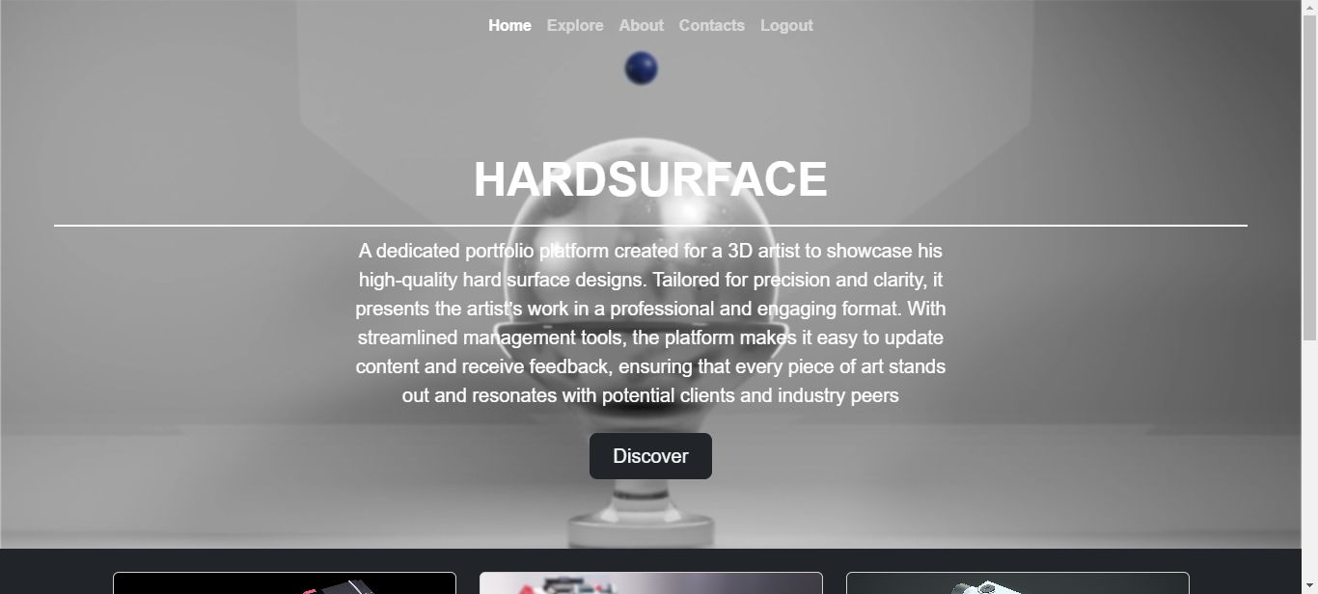

**Page:** 16

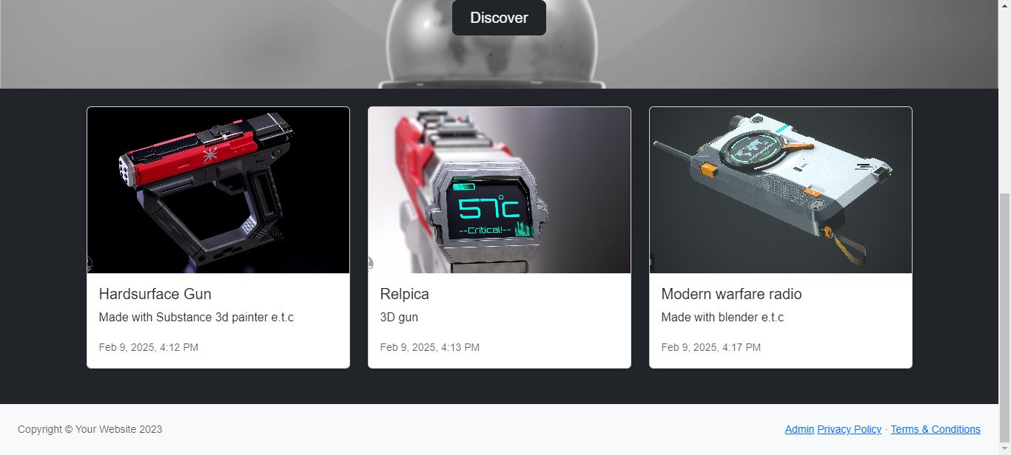

* **Model Showcase Page:** Detailed view of an individual model with interactive tools. Once a card is active or has been hovered on, the button will appear indicating that an action can be made. Then once clicked, a modal appears showing a more descriptive post that is defined by the selected card.

Page: 17

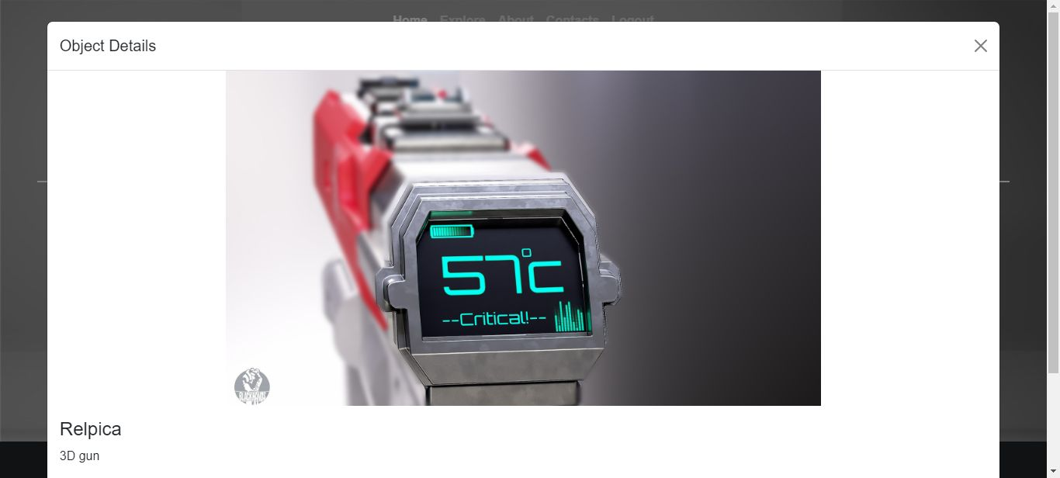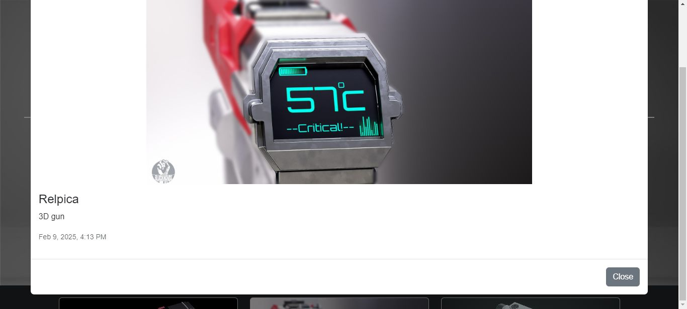

Page: 18

* **Upload Interface:** Step-by-step guide showing how to submit new models. The admin (3d Artist) can upload files from the dashboard and preview the uploaded files there.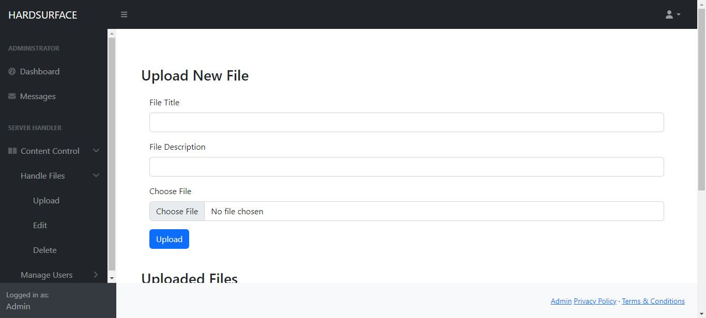

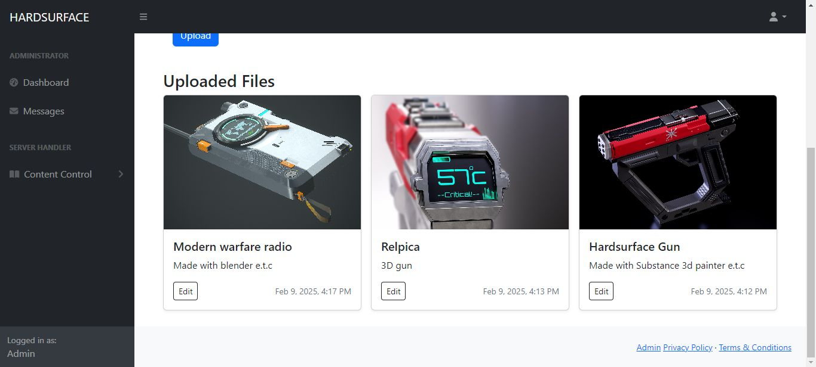

Page: 19

* **Feedback Section:** Visual representation of the commenting system. Visitors can leave a comment or feedback on the system and the admin can view all messages right in the dashboard also keeping it private and personal and stopping ordinary users from viewing this information.

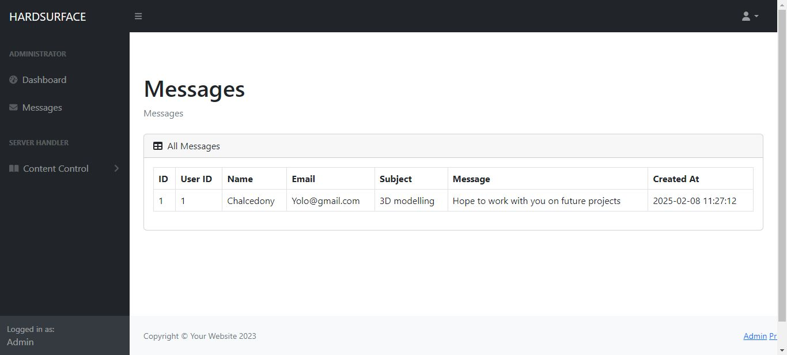

Page: 20

* **Contact Page:** The design of the inquiry form and automated response mechanism (though still needs a bit of fine tuning).

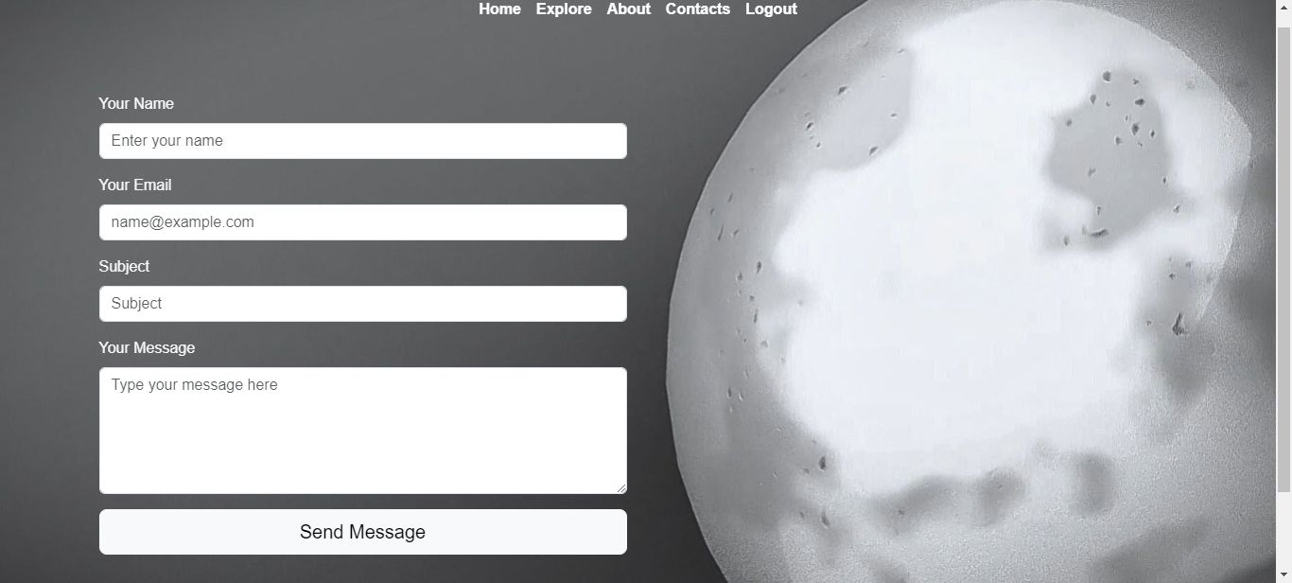

Page: 21

**Chapter 8:**

**Impact on the Client**

**Benefits Overview**

The unified platform brings several transformative benefits:

* **Time Efficiency:** The client now manages a single online presence rather than juggling multiple sites.
* **Centralized Data:** All models, lectures, and feedback are housed in one location, streamlining updates and maintenance.
* **Improved Engagement:** The integrated feedback system fosters a closer connection between the client and his audience.

**Enhanced Professional Image**

A professional, tailored website:

* **Boosts Credibility:** The polished presentation elevates the client’s professional standing.
* **Attracts Collaborations:** A centralized portfolio makes it easier for potential clients or collaborators to find and assess his work.
* **Showcases Expertise:** Detailed model pages and educational content emphasize the client’s technical skills and teaching ability.

**Workflow Optimization**

By addressing the key pain points:

* **Reduced Administrative Overhead:** The client spends less time on repetitive tasks.
* **Streamlined Updates:** Automatic synchronization between various sections ensures consistency across the site.
* **Scalable Growth:** The modular design allows the platform to grow with the client’s expanding portfolio and audience.

**Page: 22**

**Consequences of Inaction**

If the platform were not implemented:

* **Continued Fragmentation:** The client would continue to lose time and potential engagement by relying on multiple platforms.
* **Limited Reach:** The lack of a centralized system would hinder local as well as global visibility.
* **Operational Inefficiency:** The existing approach would continue to strain the client’s limited resources, affecting both creative output and educational quality.

**Chapter 9:**

**Citations and References**

**Online Resources and Inspirations**

The development of this platform was informed by research and insights drawn from a variety of reputable sources:

* **YouTube Channels:**
  + *Blender Guru* – For presentation and visual design techniques.
  + *CGMatter* – For automation insights and performance optimization.
  + *CGCookie* – For basic insight on the elements which bring to life a model or idea (3d)
  + *TechWithTim* – For absolute understanding on layering code and connections

**Additional References**

* **Industry Websites:**
  + *ArtStation* – Portfolio layout and high-quality asset display.
  + *Patreon* – Community engagement and monetization models.
  + *Gumroad* – Direct sales and digital asset distribution techniques.
  + *Sketchfab* – Interactive model viewing and annotation.

Page: 23

Additional technical references were obtained from developer forums and documentation sites such as Stack Overflow, MDN Web Docs, and PHP’s official documentation.

*End of Documentation*